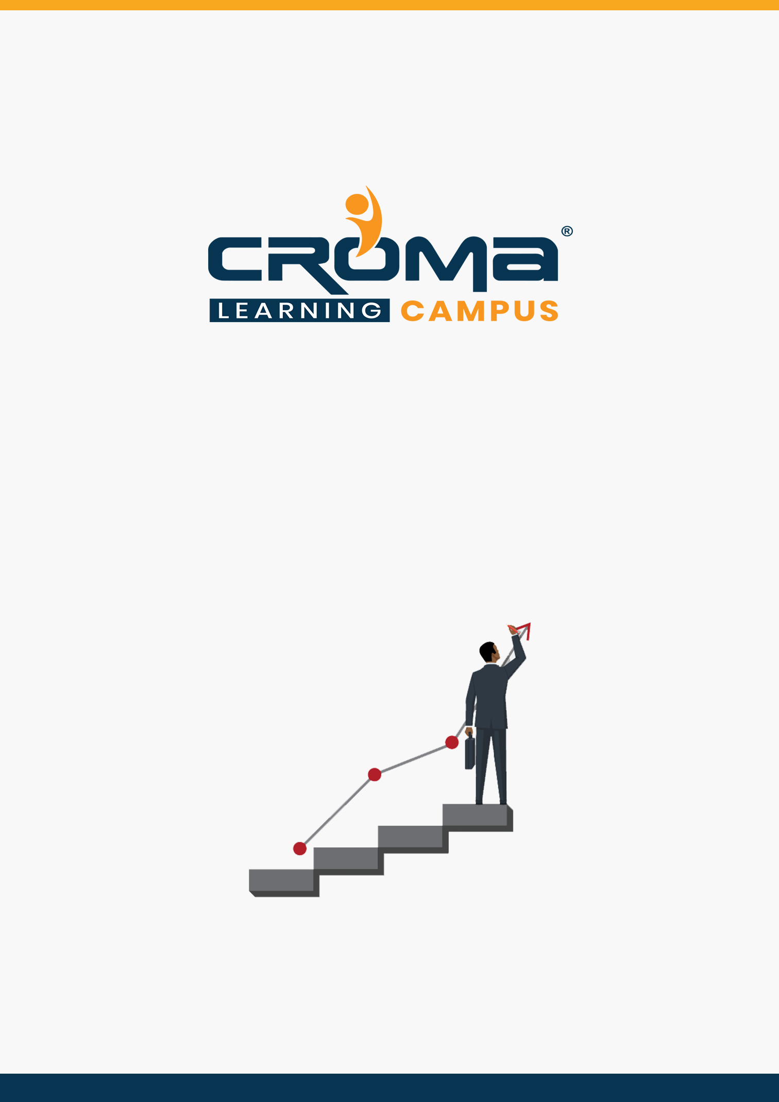

**Advanced Java Training Curriculum**

**STRUCTURE**

**www.cromacampus.com | helpdesk@cromacampus.com | +91-120-4155255**

**Advanced Java Training Curriculummmn**

*Dive deep into Advanced Java Concepts with our comprehensive Java Training Program*

**Course Objectives:**

* Learn advanced Java programming through practical sessions.
* Get an in-depth understanding of Advanced Java concepts, JDBC, JSP, XML, GUI Development, Java Graphics, using Eclipse, Web Servlets, Tomcat, Data Structures, and more.
* Get Instructor Guidance and Query Resolution Support
* Prepare for Advanced Java Certification exam and get hired by top IT industries across the globe.

**Why Join Java Training Program?**

* There are nearly 9 million Java developers in the world, and they earn a median salary of $83,975.00
* 95% of enterprises use Java for programming in some form or another
* Java runs on more than 1 billion smartphones since Google’s Android OS uses Java APIs

**Course Description:**

Java Programming language is one of the most used and most popular languages in the world of IT development. Given its properties of platform independence, object-oriented approach, reusable code and dynamic classes – Java has emerged to be the most preferred language for programmers.

The cherry on the cake is that it is quite easy to learn and implement, thus making it highly favourable in the programming community. Its popularity also stems from the fact that it was built keeping Security in mind, and thus enables programmers to write code with fewer bugs, in lesser time.

Our Java programming courses cover the length and breadth of this platform-independent. As the language enables faster coding with fewer bugs, it is the favourite of programmers. Our training course offers the expertise of Java to all who want to use it for coding at the advanced level on different devices.

To join this course, the person must-have knowledge of Core Java Concepts.

**Course Content:**

**Module 1: Introduction**

* Java Basics
* Java OOPs Overview
* Anatomy of a Class & Interface, Annotations
* Polymorphism
* Event Handling
* Internationalization
* Exceptional Handling
* Regular Expressions
* Multithread Programming
* Java Applets

**Module 2: Introduction to Enterprise Edition/J2EE**

* Distributed Multitier Applications
* J2EE Containers
* Web Services Support
* Packaging Applications
* J2EE 1.4 APIs
* SQL
* Oracle 10g XE installation
* SQL-Basics (DDL, DML, DQL)
* SQL-joins

**Module 3: HTML, JavaScript, CSS**

* HTML basics
* Form development
* JavaScript form validations
* Real-time Examples in JavaScript
* CSS implementation

**Module 4: Data Structures in Java**

* Stacks
* Queues
* Binary Trees
* Lists
* Sets
* Maps
* Sorting and Searching Algorithms
* Insertion Sort
* Bubble Sort
* Merge Sort
* Quicksort
* Linear Search
* Binary Search

**Module 5: Collection & Generics**

* Generics
  + Building Generic Classes
  + Creating Generic Interfaces
  + Building Generic Methods
  + Building Generic Classes with Different Types
  + Generic Programming Problems
* Sequential Collections
  + Collection, List, And Set Interfaces
  + The Queue and Dequeue Interfaces
  + The ArrayList Class
  + The HashSet Class
  + The TreeSet Class
  + The PriorityQueue Class
  + Sequential Collections Problems
* Associative Collections
  + The Map Interface
  + The Tree Map Class
  + The HashMap Class
  + Associative Collections – Exercise

**Module 6: Database Programming in Java**

* Installing MySQL On Windows
* Installing MySQL On Mac
* Installing Connectors
* Connecting to A Database
* Querying Data
* Creating Database/Tables
* Inserting Data
* Updating Data
* Database Programming With JDBC

**Module 7: JDBC API**

* What Is the JDBC API?
* Driver Types
* Two-tier and Three-tier Models
* Connection Overview
* Transactions
* DriverManager Overview
* Statement Overview
* Sending Batch Updates
* ResultSet Overview
* Types of Result Sets
* Concurrency Types
* Prepared Statement Overview
* Callable Statement Overview

**Module 8: Java Servlet Technology with Tomcat**

* What is Web Application?
* What Is a Servlet?
* Servlet Life Cycle
* Installing Tomcat on Windows
* Installing Tomcat on Mac
* Creating a Simple Servlet
* Sharing Information
* Using Scope Objects
* Controlling Concurrent Access
* Getting Information from Requests
* Constructing Responses
* Filtering Requests and Responses
* Programming Filters
* Customised Requests and Responses
* Specifying Filter Mappings
* Invoking Other Web Resources
* Including Other Resources in the Response
* Transferring Control
* Accessing the Web Context
* Maintaining Client State
* Session Management
* Session Tracking
* Tracking Service Requests
* Notifying Methods to Shut Down

**Module 9: Custom Tags in JSP Pages**

* Java Server Pages Technology
* The Life Cycle of a JSP Page
* Translation and Compilation
* Creating Static Content
* Response and Page Encoding
* Creating Dynamic Content
* Using Objects within JSP Pages
* Expression Language
* Deactivating Expression Evaluation
* Implicit Objects
* Literals & Operators
* Reserved Words
* JavaBeans Components
* JavaBean Classes
* Reusing Content in JSP Pages
* Transferring Control
* jsp:param Element
* Including an Applet
* Setting Properties for
* Groups of JSP Pages
* What Is a Custom Tag?
* Types of Tags
* Tags with Attributes
* Tags with Bodies
* Tags That Define Variables
* Communication between Tags
* Tag Library Descriptors
* Declaring Tag Files
* Declaring Tag Handlers
* Declaring Tag Attributes for Tag Handlers
* Declaring Tag Variables for Tag Handlers
* Programming Simple Tag Handlers
* Including Tag Handlers in Web Applications
* Cooperating Tags

**Module 10: XML programming**

* Introduction to XML
* Robustness & Extensibility
* XML Syntax & Documents
* XML Applications
* Elements and Tags
* Text and Attributes
* XML Declaration & Comments
* Processing Instructions
* Entities & Namespaces
* DTDs & Schemas
* Style sheets & XSL
* SOAP, Writing XML with Java
* Output Streams, Writers, and Encodings
* Converting Flat Files to XML
* Reading XML
* Input Streams and Output Streams

**Module 11: Network Programming**

* Working with URLs
* Socket Programming Example
* Socket Server Programming
* Client Server Programming
* Network Programming Problems

**Module 12: GUI Programming with SWING**

* A Simple Example
* Working with Text Fields
* Working with Buttons
* Working with Lists
* Working with Scroll Panes
* GUI Development with Swing Problems

**Module 13: Graphics in Java**

* Drawing Lines
* Drawing Shapes
* Working with Color
* Java Graphics problems

**Module 14: Using Eclipse**

* Installing Eclipse on Windows
* Installing Eclipse on Mac
* Hello World
* Overview of The Eclipse IDE
* Entering Programs
* Code Generation
* Debugging

**Module 15: Placement Guide**

* What is an Interview?
* Tips to clear an Interview
* Common Interview questions and answers
* Advanced Java Interview Questions and Answers
* Resume Building Guide
* Attempt for Advanced Java Global Certification Exam
* Start applying for Jobs